Technical Specification for Identity Module
By KANKIPATI Nagavarma

Contents

Description: 2
Objective: 2
Scope 2
Application flow: 3
Data structure 3
Download project 4
Final Executed Results: 4

Description:
The report contains the details of identity manager application. The main functionalities of creating the application is to create, modify, list and delete identities and store in database.

Objective:
The main goal of this project is to develop an application using Java which can automatically connect to a database and store information in the database and to list, modify and delete the information in the database.

The following are the objectives:
- Login admin a user
- Create an Identity
- Modify all Identity
- Delete for an identity
- List an Identity
- Quit the application

Scope
By login in the application, It should on let admin users to manage identities or than admin no other users can only have read permissions but not edit permissions.
Once after successful login as admin
- Once you enter option ‘a’ it will allow you to create a user identity by asking enter ‘uid’, enter ‘display name’, enter ‘your email id’
- Once you enter option ‘d’ it will list all the users that you have created
- Once you enter option ‘b’ it will allow you to modify by asking you to enter ‘uid’, enter ‘display name’, enter ‘your email id’
  - The entered ‘uid’ should be already created by the user to modify if not it will not let you to modify.
- Once you enter option ‘c’ it will allow you to delete by asking you to enter ‘uid’.
  - The entered ‘uid’ should be already created by the user to delete if not it will not let you to delete.
- Once you enter option ‘e’ you will exit from the application.

Application flow:
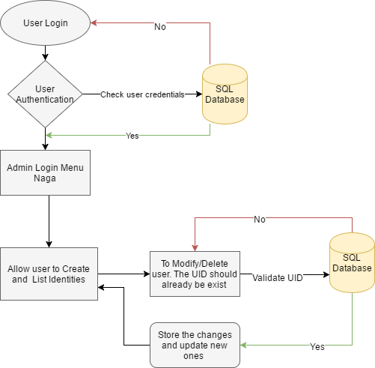

Data structure
Install WAMP server and The database used is MY SQL, After installing WAMP server Please click phpMyadmin and then you will be able to screen use below login credentials.

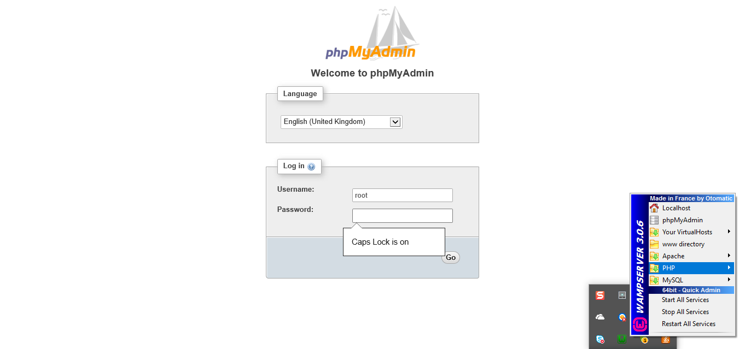
User name: root
Password:
- 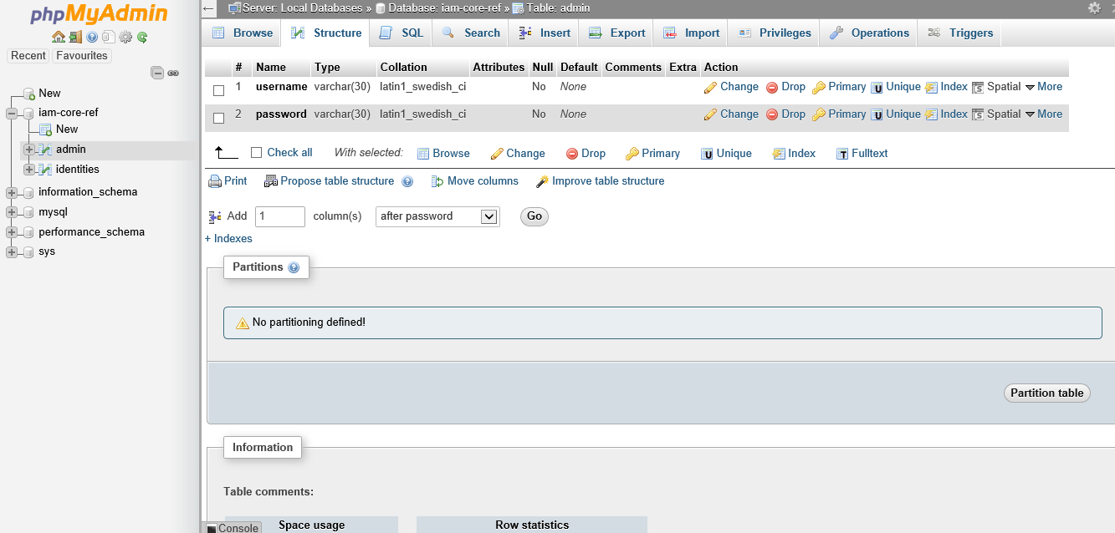
- 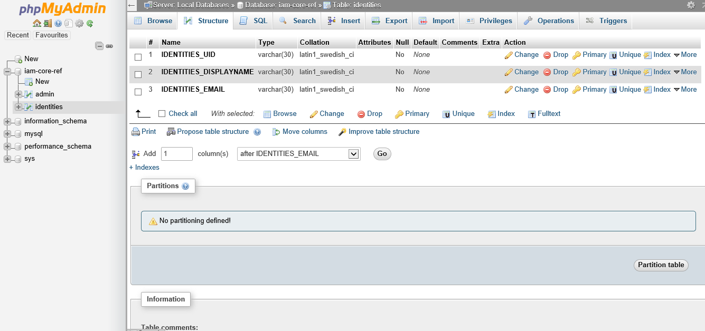
- 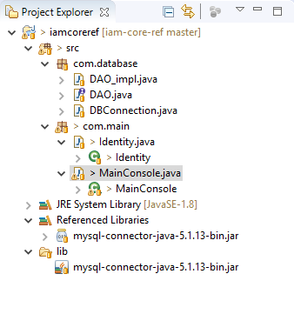

Download project
- Please use the following Github link
- Github: https://github.com/Kankipati/iam-core-ref.git pull it to your local repository.

Final Executed Results:
Login:
The final results of my project are as follows:
- The desired ADMIN input to validate the application the username: naga and password: naga
  - 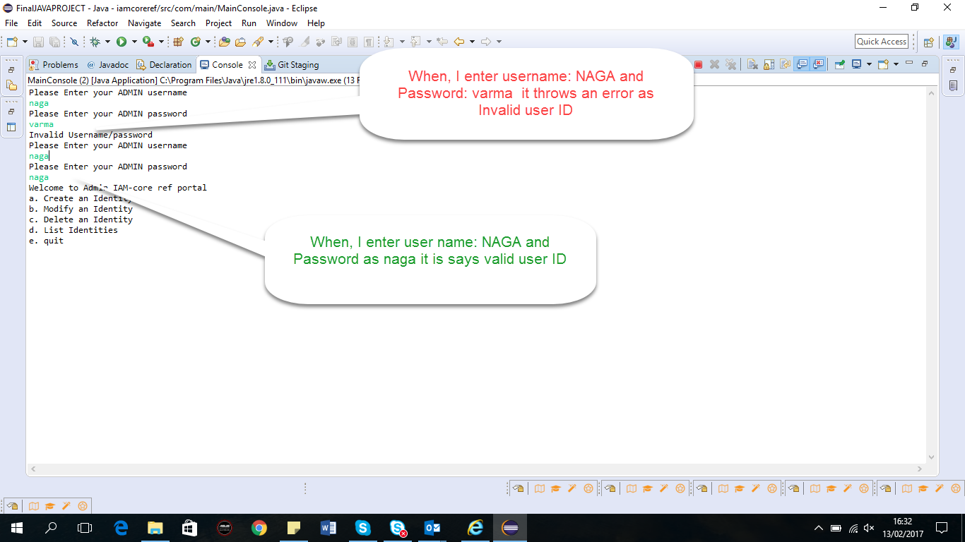
- Create Identity:
- I have created 5 Identities and listed all those 5 Identities
  - 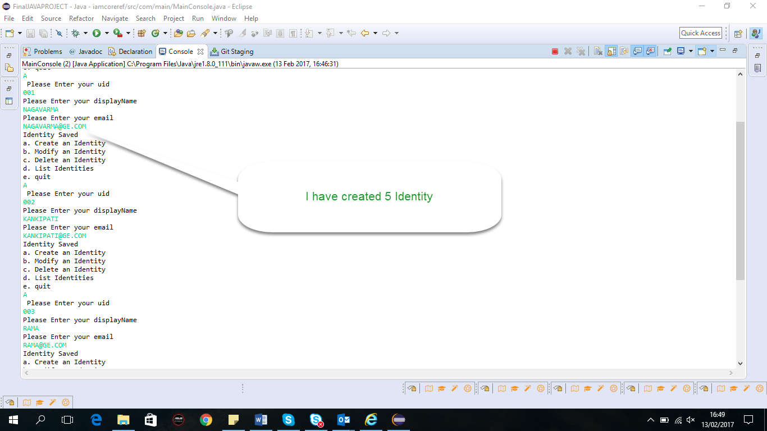

- List Identity:
  - 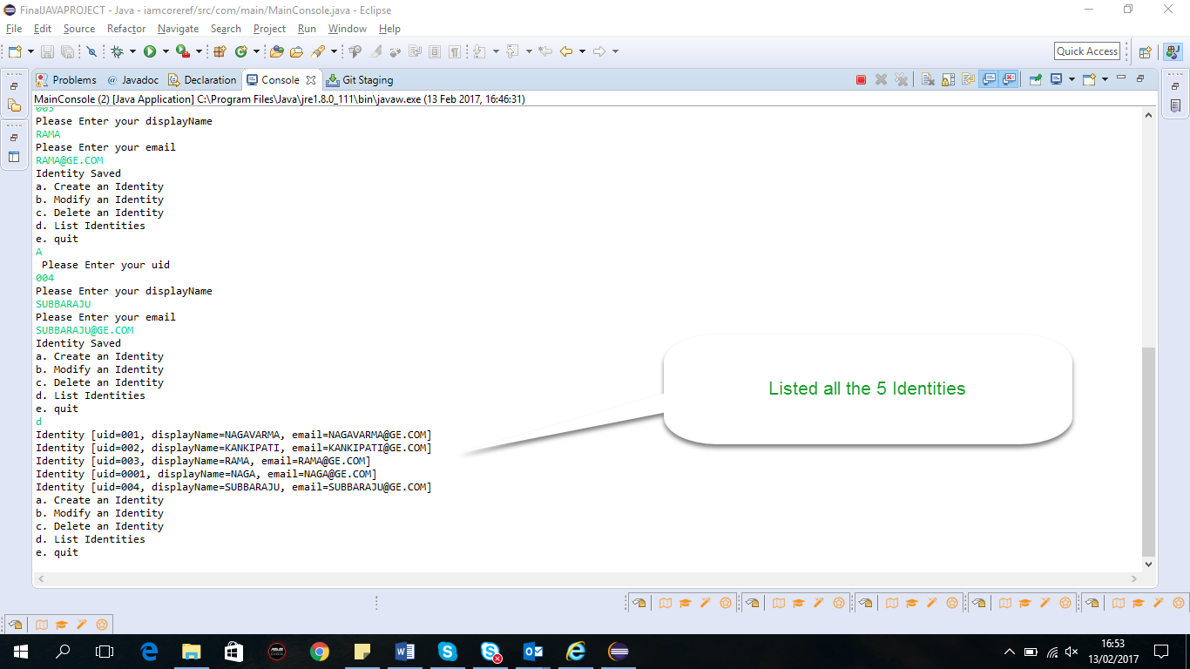
- Modify Identity:
- I have modified 1 Identity and listed it
  - 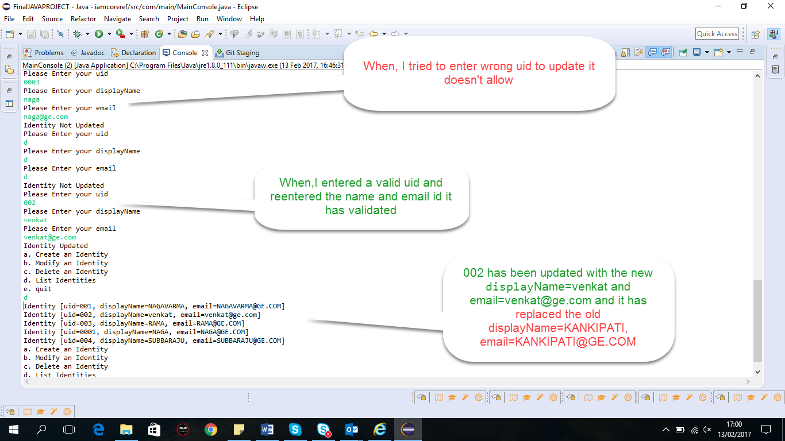

- Delete Identity:
- I have used delete identity and have successfully deleted 002 and 0001 identities
  - 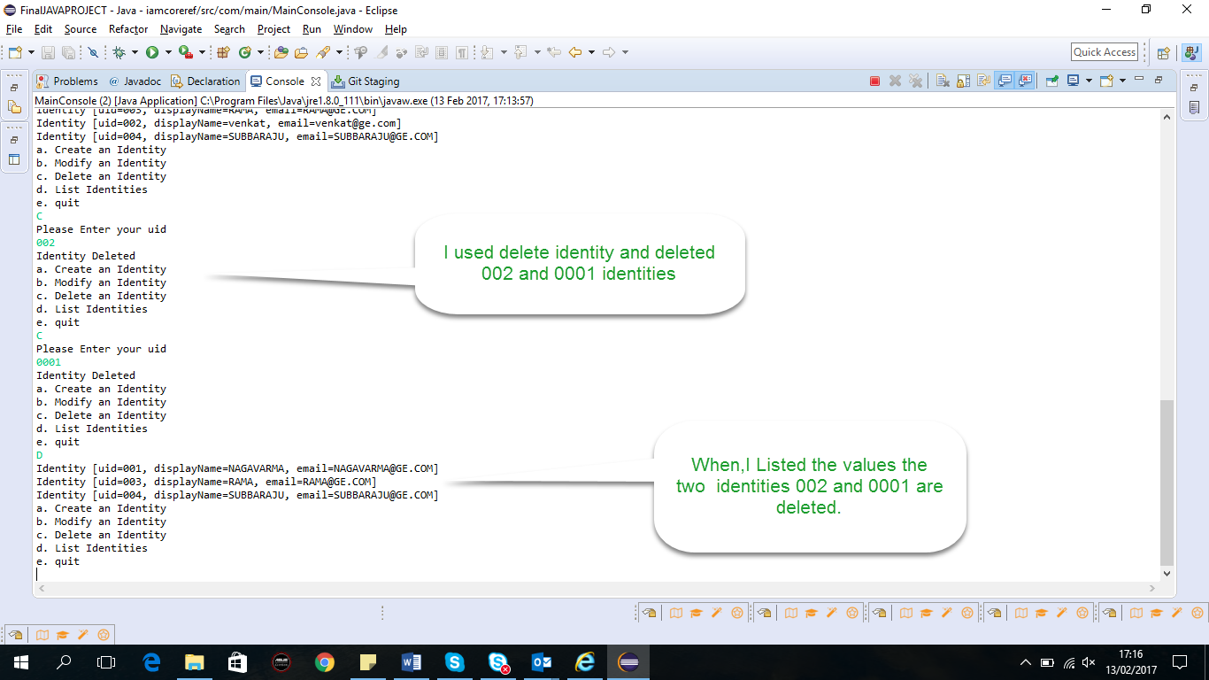
- Logout Identity:
- I have used quit option and have successfully ended the application
  - 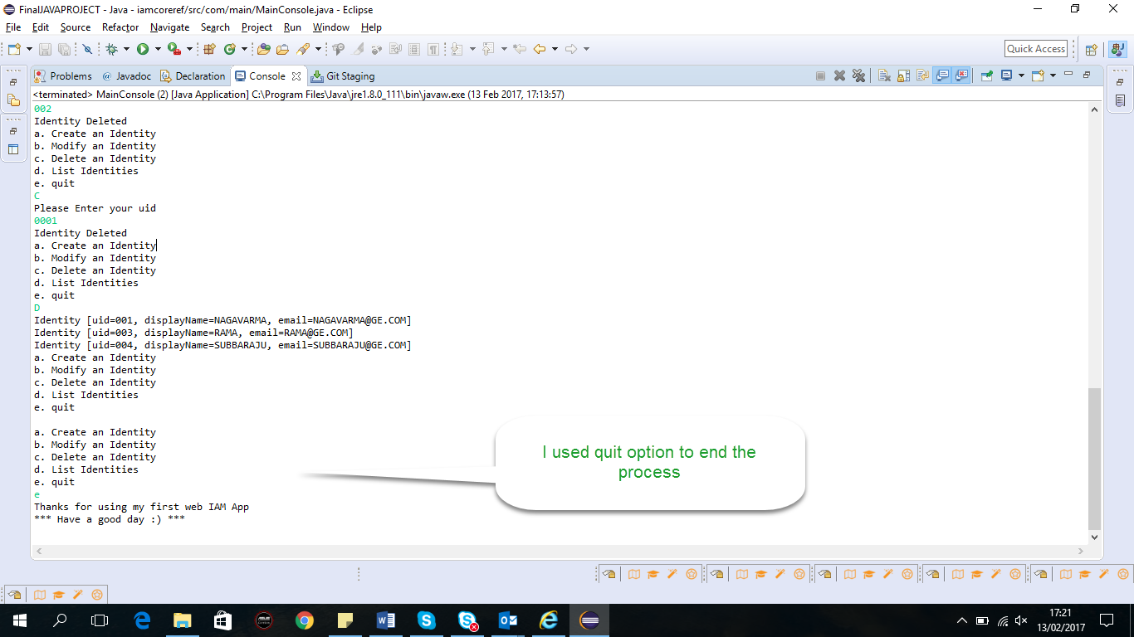

- Final output is updated in the database:

- 